**Task 1: Import movies.json into mongodb server into a database named entertainment and a collection named movies.**

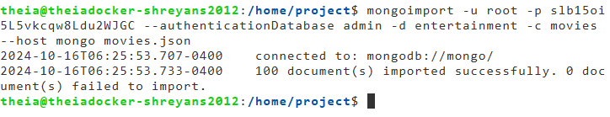

### Task 2: Write a mongodb query to find the year in which most number of movies were released

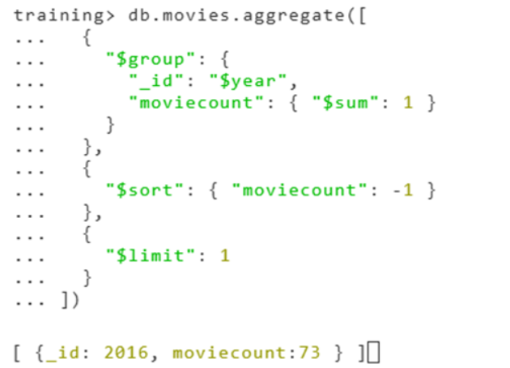

### Task 3: Write a mongodb query to find the count of movies released after the year 1999

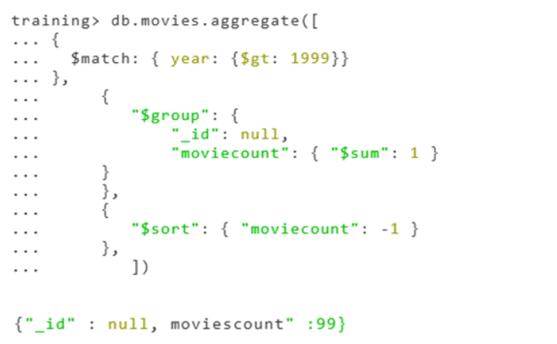

### Task 4: Write a query to find out the average votes for movies released in 2007

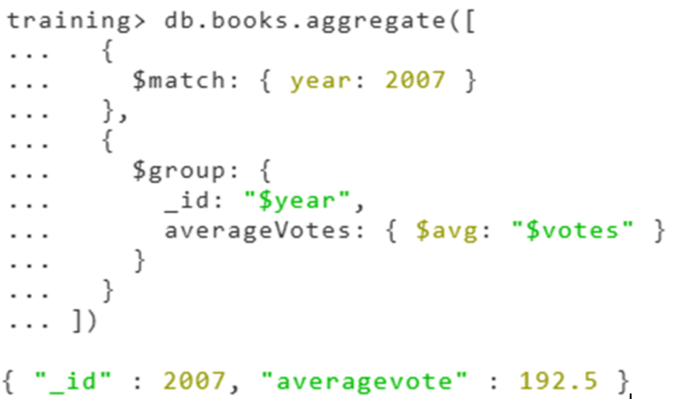

### Task 5: Export the fields _id, title, year, rating and director from the movies collection into a file named partial_data.csv

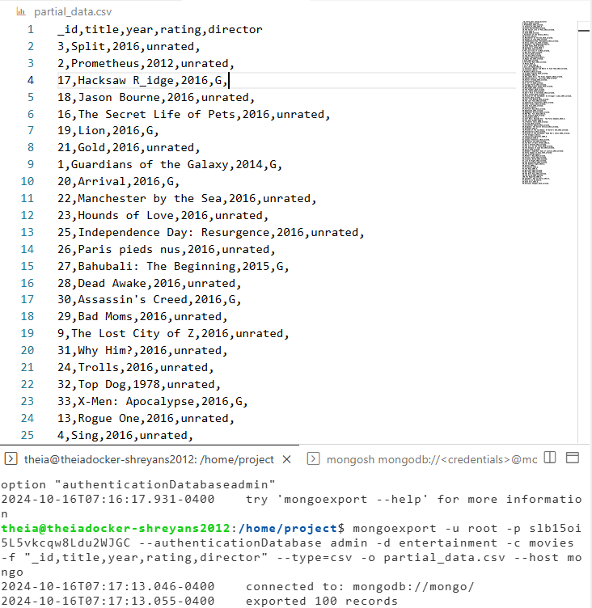

### Task 6 - Create a keyspace named entertainment

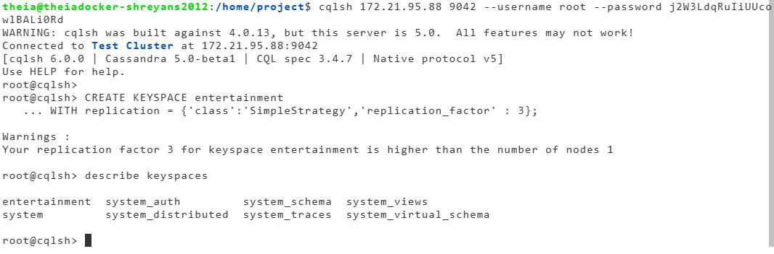

### Task 7 - Import partial_data.csv into cassandra server into a keyspace named entertainment and a table named movies

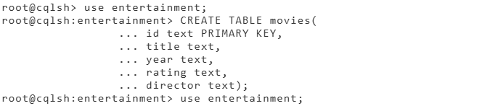

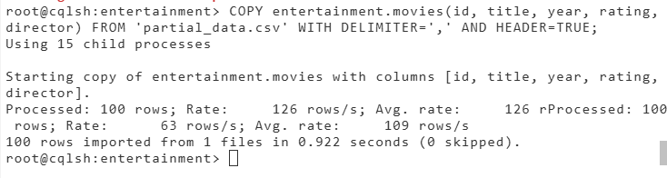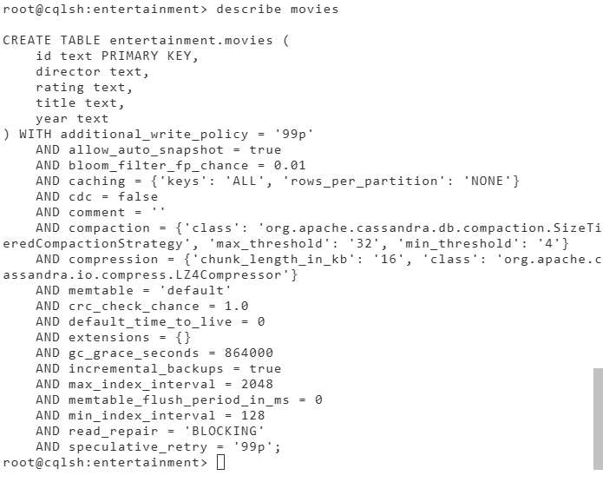

### Task 8 - Write a cql query to count the number of rows in the movies table

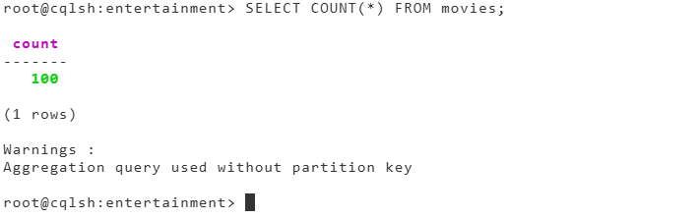

### Task 9 - Create an index for the rating column in the movies table using cql

`````



### Task 10 - Write a cql query to count the number of movies that are rated 'G'.

